



**EXECUTIVE SUMMARY:**

Company Name: Ascon Constructions.

Working Areas: Infrastructure Development i.e. Construction of Buildings, Apartments, School, Hospitals, Bungalows, Roads, Heavy structure work etc.

Worker Strength (2020) - 90+ General Labors.  
 50 Carpenters, 40 Fitters.  
 4 Supervisors, 2 Safety Engineer.  
 2 Engineers. And other Contract basis  
 workers.

Machinery and Equiptments:  
 3 Lifts & Mixture, 2 sets of Automated Steel Bending Machine, 2 sets of Automated Steel Cutting Machine, Safety Gears etc.

Year Established: 1994

GST No: 27ADCPC0440M1ZW

PAN No: ADCPC0440M

Office Address: Commercial Unit No.101, Sector no.09, Plot no.178, Ulwe, Navi Mumbai 410206.

Contact details: 8097111916

Email Id: asconconstructions01@gmail.com

**INTRODUCTION:**

Founded in 1994, Mumbai based Ascon Construction provides general contracting, construction management and pre-engineered building services to a broad range of commercial and industrial clients. Anchored by loyal employees who are dedicated to providing superior service, and grounded in the philosophy that honesty and integrity are as important as the bottom line, Ascon Construction has enjoyed an impeccable reputation for over 20 years. We have never failed to complete a project. We have done all type of building work and we do work in Labor, with material and Lock-key.

Ascon Construction is a company that has built a strong reputation for delivering a quality service, on time, and at a competitive price.

**FINANCIAL HIGHLIGHTS:**

The Gross Annual Turnover of M/s ASCON CONSTRUCTION during the last Four financial years is as below:-

*Financial Year Gross Turnover*

* 2006-07 - 25 Cr.
* 2007-08 - 18 Cr.
* 2008-09 - 28 Cr.
* 2009-10 - 27 Cr.
* 2010-11 - 16 Cr.
* 2011-12 - 12 Cr.
* 2012-13 - 8.70 Cr.
* 2013-15 - 18 Cr.
* 2015-16 - 12.5 Cr.
* 2016-17 - 12.7 Cr.
* 2017-19 - 35 Cr

**WORK PROFILE:**

|  |  |  |  |
| --- | --- | --- | --- |
|  | | | |
| PROJECT DATE | PROJECT NAME | SITE ADDRESS | DEVELOPER |
| 1994-95 | Anand Mangal | G+7, Plot no.17,Sec.19,Nerul (E) Navi Mumbai | Harish Kambodia |
| 1994-95 | White House | G+12, Plot no.07,Sec.19,nerul(E) Navi Mumbai | Eveready Builders and Developers |
| 1995-96 | Elite Park | G+11, Plot no.36,Sec.19,nerul(E) Navi Mumbai | Jas Construction |
| 1995-96 | Balaji Darshan | 15, Plot no.107/108,Sec.18,nerul(W),Navi Mumbai | Jas Construction |
| 1995-97 | Anmol Heights | G+4/3 wings, Plot no.127/128/129,parsik hill, C.B.D Belapur Navi Mumbai | Jas Construction |
| 1997-98 | Balaji Nivas | G+4/2 wings, Plot no.108/109,sec.06,New panvel Navi Mumbai | Eveready Builders and Developers |
| 1997-98 | Prajapati Arcade | G+7/3 wings, Plot no.115,sec.18,new panvel Navi mumbai | Prajapati Builders and Developers |
| 1997-98 | Balaji Apartments | G+7, Plot no.15,sec.11,new panvel Navi Mumbai | Eveready Builders and Developers |
| 1998-99 | Balaji Krupa | G+7, Plot no.18,sec.19,nerul Navi Mumbai | Eveready Builders and Developers |
| 1999-2000 | Shelter Co-op Housing Society | G+5/2 wings, Plot no.116-B,sec.21,nerul Navi Mumbai | Shelter Builders and Developers |
| 2000-01 | Raj Residency | G+15/2 wings, Laboratory garden,Malad (W), Mumbai | Raj Builders and Developers |
| 2001-02 | Shelter Complex | G+7/2 wings, Plot no.46,sec.50 old, nerul (W) Navi Mumbai | Shelter Builders and Developers |
| 2001-02 | Shelter Hotel | G+5, Plot no.118,sec.19,vashi Navi Mumbai | Shelter Builders and Developers |
| 2002-03 | Shelter House | G+4/2 wings, Plot no.14,sec.08,ghansoli Navi Mumbai | Shelter Builders and Developers |
| 2002-03 | Krishna Kamal Chs | G+7, Plot no.05,sec.05,nerul (E) Navi Mumbai | Jas Construction |
| 2003-04 | Thakur Apartment | G+7, Plot no.36,sec.36,palm beach road Navi Mumbai | Jas Construction |
| 2003-04 | bungalow 22,000 sq fit | G+3, Plot no.106, tungarli, opp.bharat shah bungalow, lonavala | Guru Krupa Ltd. |
| 2005-06 | Bunglow Basement+3 Floor with Swimming pool | 2 acres Plot, Basement+3th, opp.Surya international restaurent/hotel Mahabaleshwar | Karuna Engineering |
| 2006-07 | Ryan International School | Ryan International school, Plot No,1/A,Nerul,Navi Mumbai 400706 | Ryan International |
| 2006-07 | Doctor House | G+6, Plot no.14,sec.18,koparkhairne,navi Mumbai | Eveready Builders and Developers |
| 2007-08 | Ryan International School | Ryan International school, Sector-06, Sanpada Navi Mumbai | Ryan International |
| 2007-08 | Ryan International school | Ryan International School, Airoli, Navi Mumbai | Ryan International |
| 2008-09 | Ryan International School | Ryan International School, Khanda Colony, Navi Mumbai | Ryan International |
| 2008-09 | Ryan International School | Ryan International School, New Panvel, Navi Mumbai | Ryan International |
| 2008-09 | Ryan International School | Ryan International School, Rabale, Navi Mumbai | Ryan International |
| 2008-09 | Anantha Apartment | G+15, plot no.1, sec.36, nerul (W) Navi Mumbai. | Eveready Builders and Developers |
| 2008-09 | City Homes | G+7, plot no.127, sec.30, Owe gaon, Khargar,  Navi Mumbai | Shelter Builders and Developers |
| 2009-10 | Ahilya Datta Arcade | g+7, plot no.136-D, sec.19, Kharghar, Navi Mumbai | Ahilya Enterprises. |
| 2009-10 | Sunrise Apartment | G+7, plot no.77, sec.28,Nerul, Navi Mumbai | Sunrise Builders and Developers |
| 2009-11 | Thakur Residency | G+18, plot no.136, sec.36 Nerul (W) Navi Mumbai | Thakur Realtors |
| 2009-2011 | Karuna Engineering | G+12, plot no.52, sec.44A, Nerul(W). Navi Mumbai. | Karuna Engineering |
| 2010-11 | Personal Bunglow | G+4, bunglow sec.8, plot no.77, Vashi Navi Mumbai. | Vijay Patil |
| 2010-11 | Priyanka Builders | G+4, Plot no.26, sec.26, Vashi, Navi Mumbai | Priyanka Builders and Developers |
| 2011-12 | A.N Hill View | G+14, plot no.69/70, sec.27,Nerul Navi Mumbai. | A.N Associates |
| 2012-13 | Balaji Shraddha | G+7t, plot no.16-B, sec.8, Ulwe, Navi Mumbai | Reliable Builders and Developers |
| 2013-15 | Prabhat Heights | G+7, Plot no.178, Sec-09, Ulwe, Navi Mumbai | Prabhat Builders and Developers |
| 2013-14 | Sai Krupa | G+7, Plot no.142,sec.02,Ulwe, Navi Mumbai | A.N Associates |
| 2014-15 | A.N Heights | G+15, Plot no.76, sec.50, Nerul, Navi Mumbai. | A.N Associates |
| 2014-15 | Madarsa Masjid | 21, Turbhe, Navi Mumbai | Madarsa Foundation |
| 2014-15 | Unique Residency | G+5, Plot no.98/1, A-2, Chambar Khend, Mahad, Maharashtra | Unique Construction |
| 2015-16 | Radcliffe School | G+3, Radcliffe School, Hirandani Estate, Thane Navi Mumbai | Radcliffe School Association |
| 2016-17 | Radcliffe School | G+3, Radcliffe School, Chovisovadi, Pune, Maharashtra | Radcliffe School Association |
| 2017-18 | Zaherabad | G+4, Musanagar, Zaherabad, Telangana | Abdul Majeed |
| ONGOING | AL Raha Smart Homes | G+5, Sy No.78/1 & 2, Brindavan Mam Garden, Malgatti, Gulbarga, Karnataka | Apple Realty |
| ONGOING | Affordable Houses | G+3, Plot No.84,25,26,27,28,29,30 Aland Road, Kalaburagi, Gulbarga, Karnataka | Honeyland Developers Pvt Ltd. |
| ONGOING | Mapple Ivy | G+15/2 wings, Plot no.95, Sec-09, Ulwe, Navi Mumbai, Maharashtra | Yushan Realty Venture |
| ONGOING | STAR HEIGHTS | G+14, Sector 52, Plot no.37, Dronagiri, Navi MumbaI, Maharashtra | Reliance Builders and Developers |
| ONGOING | Olive | G+27, B-3/102, Greenfield, Mapkhan nagar, Marol Andheri (E) Mumbai 400 059 | M.S Shah Builders and Developers. |
| ONGOING | Viraj Heights | G+36 and G+27, (2 Towers) Viraj Heights, Dhobhighat Opp.Saraswat Bank, Kopri, Thane East, 400 603 | Viraj Buildcons. |
| ONGOING | Guru Nagar Apartments | G+5 Floors, Guru Nagar Colony, Sadashivpet, Mumbai – Hyderabad Highway, Telangana | Ascon Constructions |

**PROJECTS GALLERY:**

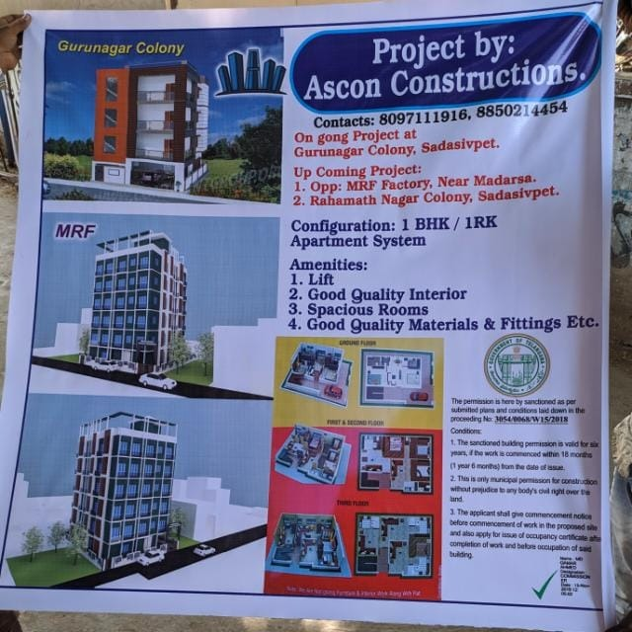 **Projects in Telangana.**

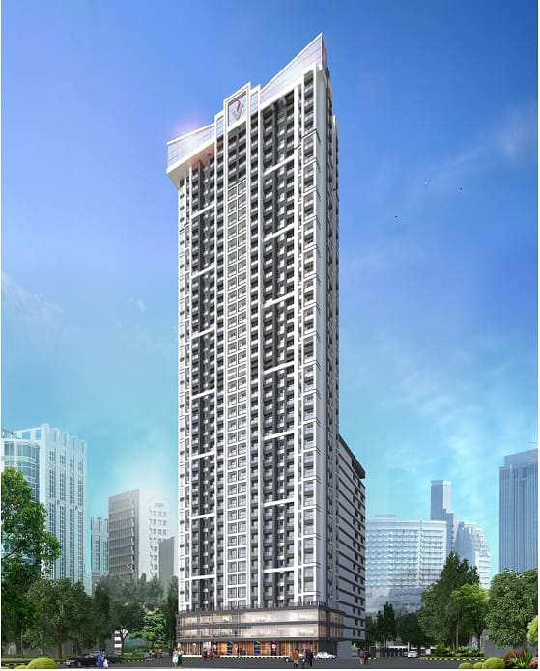 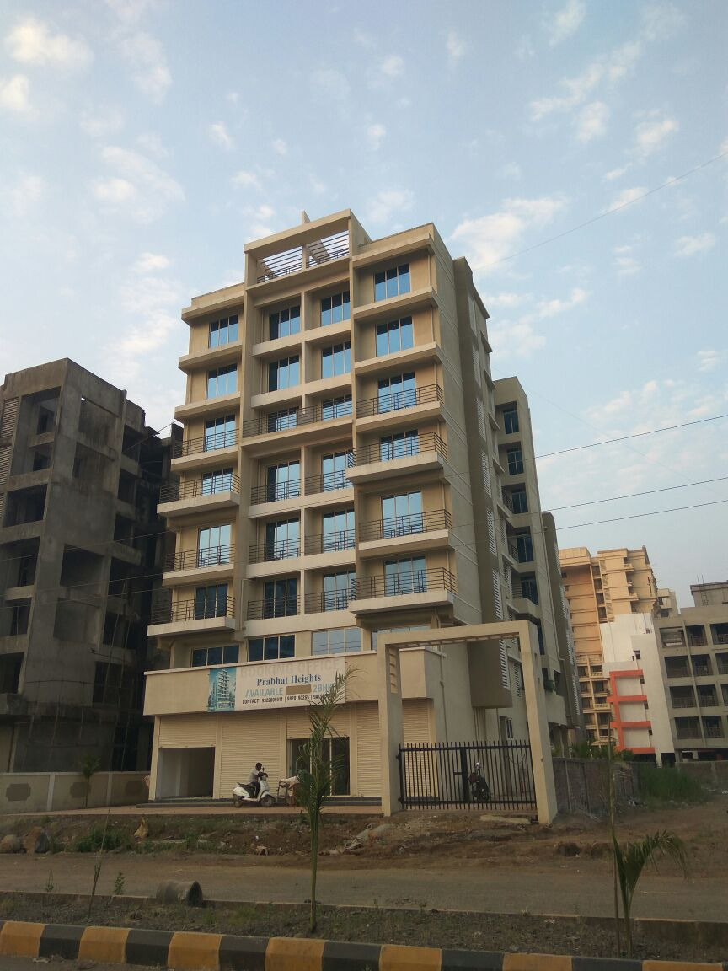

**VIRAJ HEIGHTS, KOPRI PRABHAT HEIGHTS, ULWE**

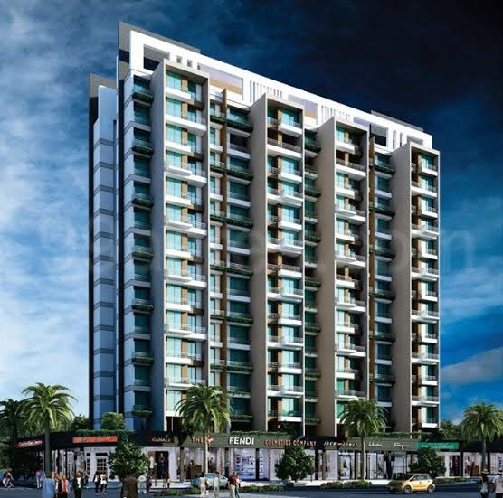

**MAPLE IVY, ULWE**

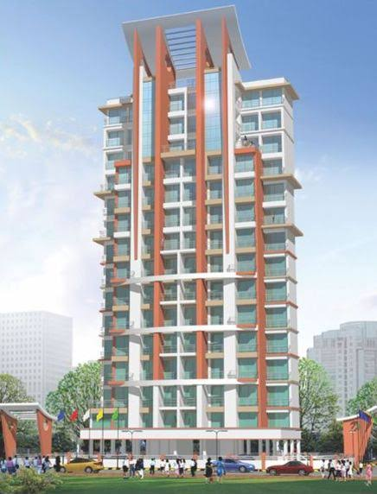 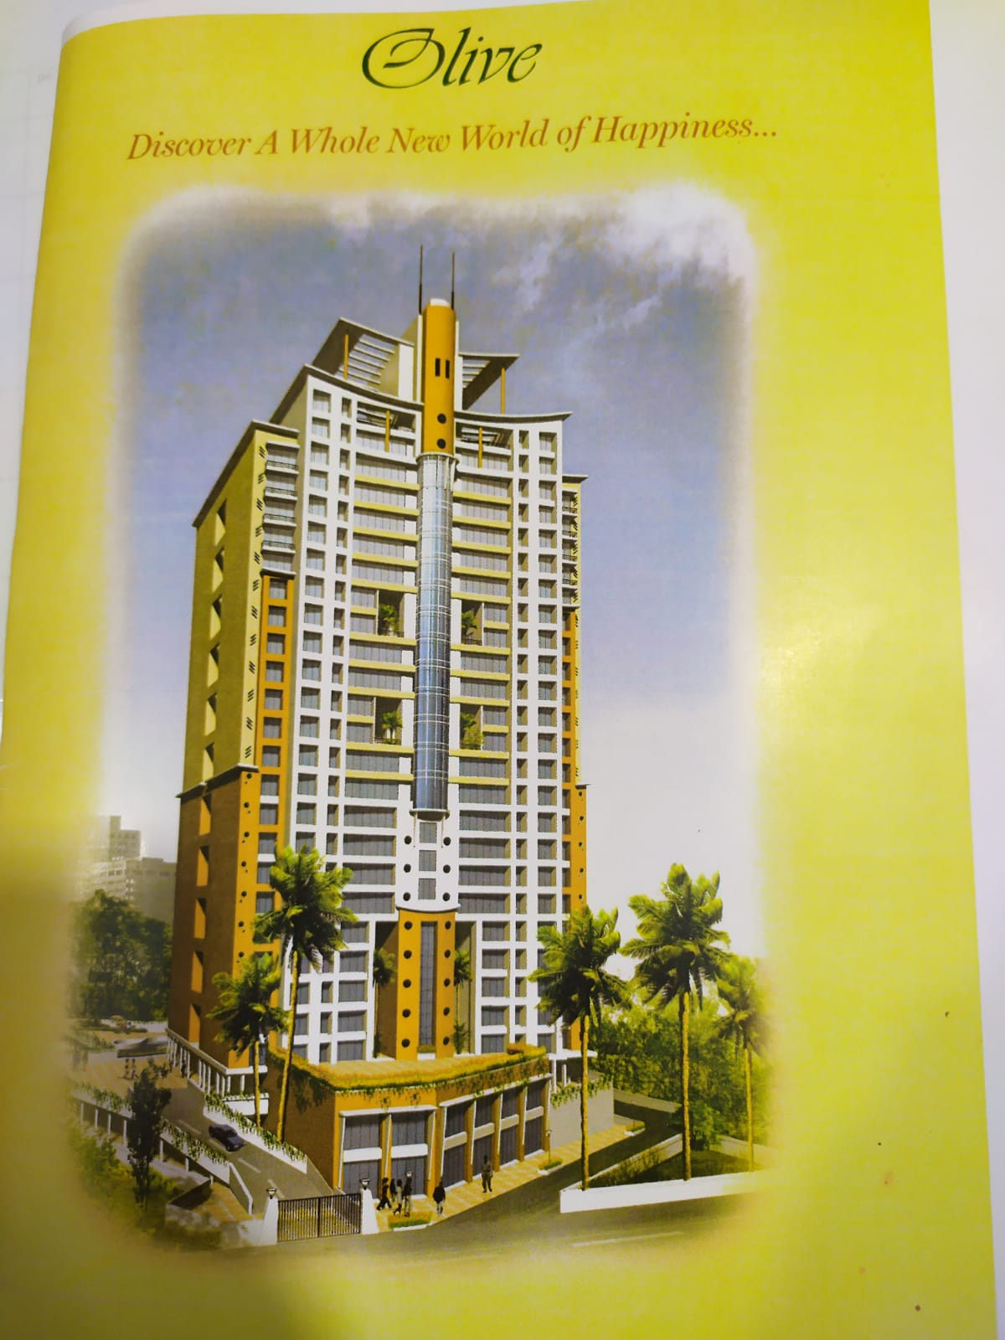 **A.N HILLVIEW, SEAWOODS Olive, Kandivali**

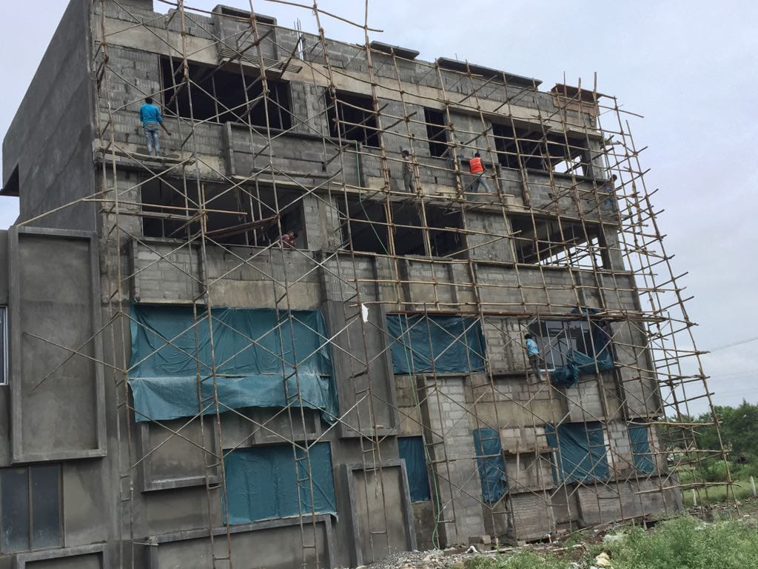

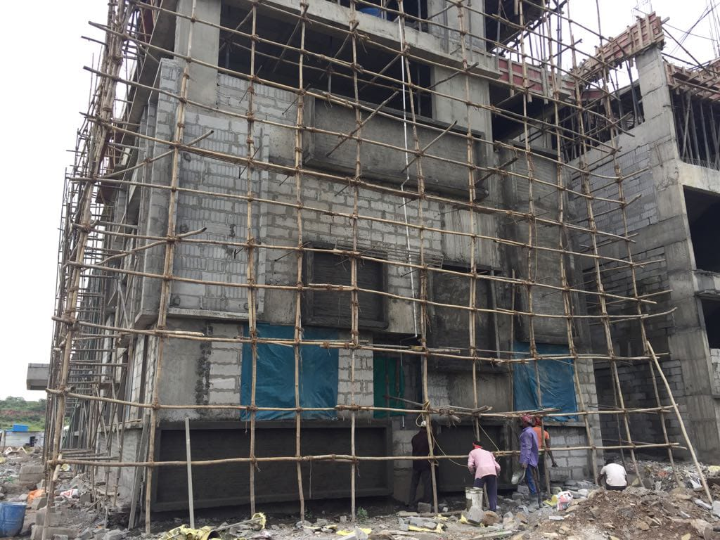

**RADCLIFE SCHOOL, PUNE**

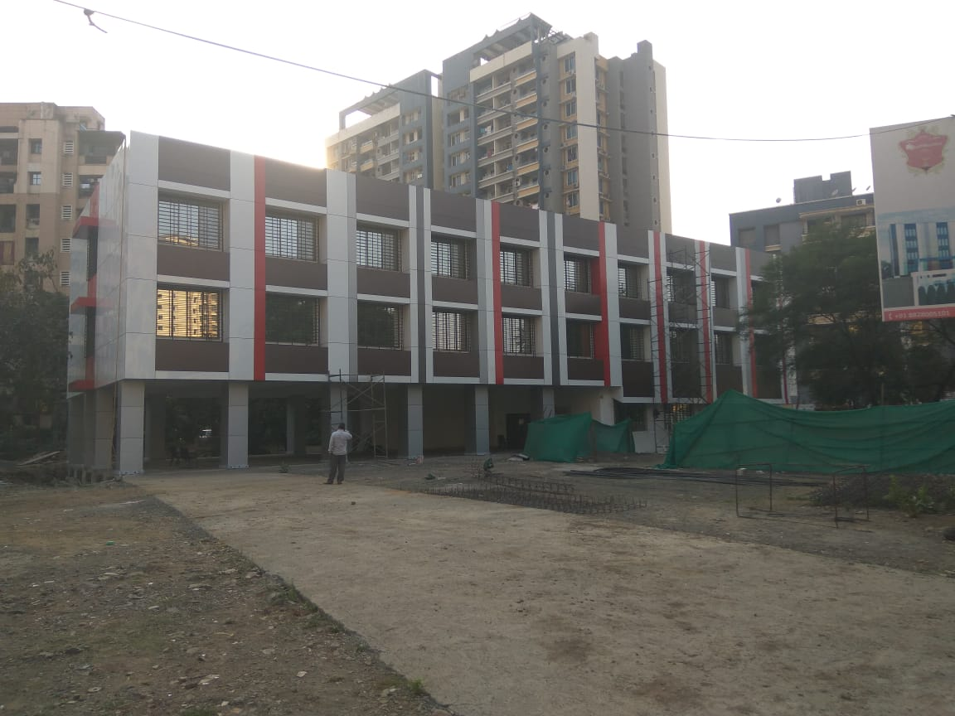

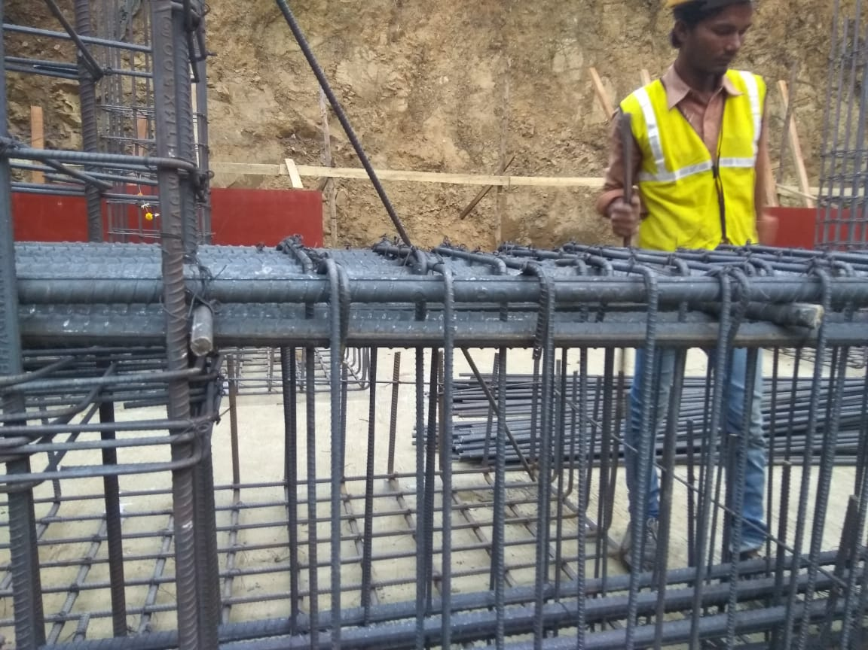 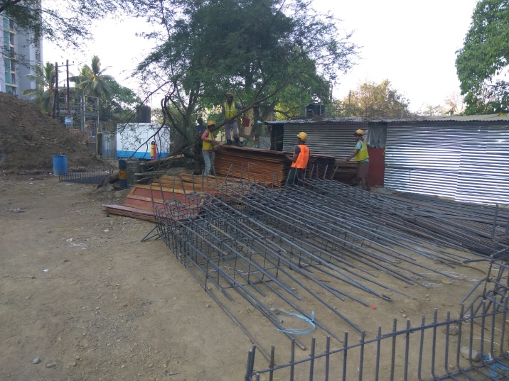

**RADCLIFFE SCHOOL, THANE**



